I tested against different values for each sport.

Basketball:

Free Throws Made: 5

Free Throws Attempted: 7

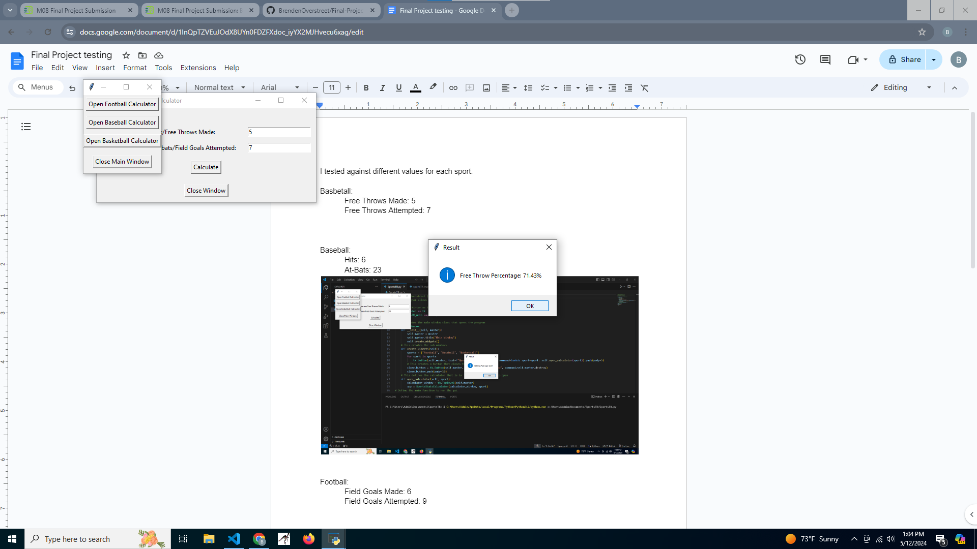

Baseball:

Hits: 6

At-Bats: 23



Football:

Field Goals Made: 6

Field Goals Attempted: 9

